

NAME : STEPHEN KIMANI

ADMMISSION: BSCCS/2024/57444

COURSE : BACHELOR OF SCIENCE IN COMPUTER SCIENCE

UNIT CODE: BIT 4139

UNIT NAME: ETHICAL HACKING AND COUNTERMEASURES

LECTURER: MICHAEL NYORO

SEMESTER /ACADEMIC YEAR: SEMESTER 6

Table of Contents
Kenya Red Cross 3
ASSIGNMENT ONE- 3
Domain Registration Information 3
Domain IP Address Resolution 3
DNS Information Lookup 4
Email and Subdomain Enumeration 5
Website Technology Identification 5
Student Reflection 6
– MY LOCAL MACHINE (KALI LINUX) 6
ASSIGNMENT 2 6
Open Port Discovery 6
Service Version Detection 6
Operating System Detection 7
Vulnerability Assessment 7
ASSIGNMENT 3 9
DOCKER INSTALLATION VERIFICATION 9
DVWA Image Download 9
DVWA Login Interface 10
DVWA Database Setup 10
SQL Injection Module 11
SQL Injection Test Results 11
Retrieval of Additional User Records 12

INFORMATION GATHERING (Kenya Red Cross)

ASSIGNMENT ONE-

Domain Registration Information

Domain IP Address Resolution
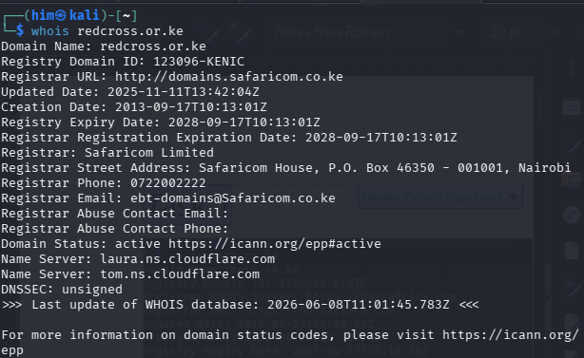Figure 1: The WHOIS command retrieved domain registration information for the target organization.

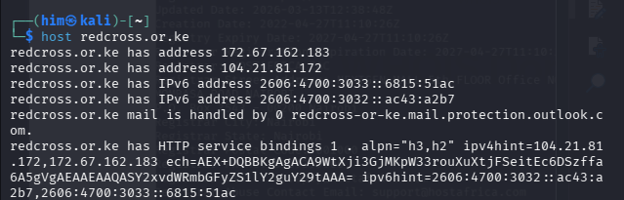Figure 2: The Host utility resolved the target domain to its associated IP address.

DNS Information Lookup
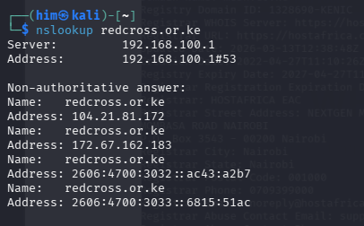Figure 3: The NSLookup command retrieved DNS information for the target domain.

Email and Subdomain Enumeration
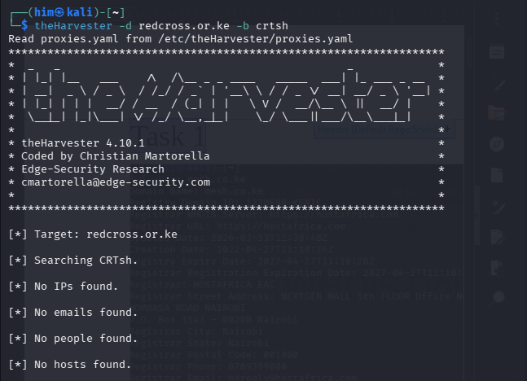Figure 4: TheHarvester performed passive reconnaissance but did not identify any publicly available emails or hosts.

Website Technology Identification
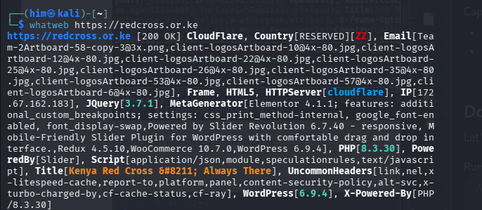Figure 5: WhatWeb identified technologies running on the target website.

Student Reflection
This assignment improved my understanding of reconnaissance by showing how publicly available information can be collected using ethical hacking tools. I learned how domain details, DNS records, and website technologies can provide valuable insights while emphasizing the importance of conducting information gathering responsibly.

– SCANNING AND ENUMERATION (MY LOCAL MACHINE)

ASSIGNMENT 2

Open Port Discovery
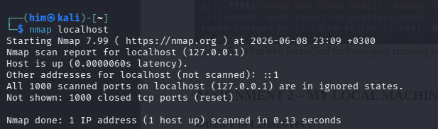Figure 6: Nmap identified open ports and active services on the host machine

Service Version Detection
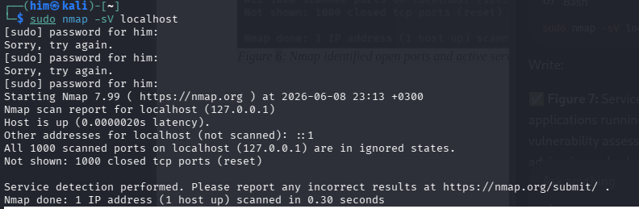Figure 7: Nmap detected service versions running on open ports.

Operating System Detection
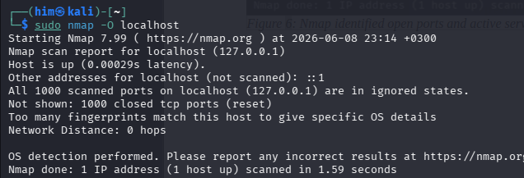Figure 8: Nmap identified characteristics of the host operating system.

Vulnerability Assessment
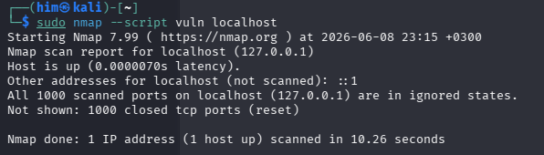Figure 9: Nmap vulnerability scripts assessed the host for potential security weaknesses.

Student Reflection
This exercise enhanced my practical skills in using Nmap to identify open ports, running services, and operating system information. It demonstrated how scanning helps security professionals understand a system’s attack surface and identify potential areas that require protection.

ASSIGNMENT 3- SQL Injection

DOCKER INSTALLATION VERIFICATION
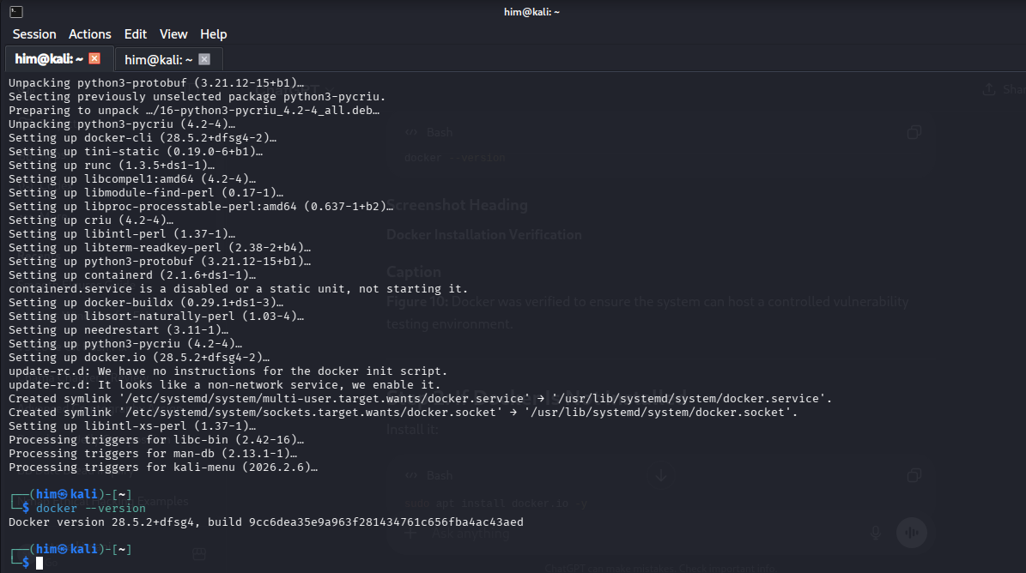Figure 10: Docker was verified to ensure the system can host a controlled vulnerability testing environment.

DVWA Image Download

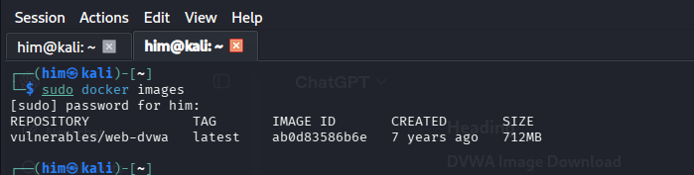Figure 11: The DVWA Docker image was successfully downloaded and made available for deployment in the local testing environment.

DVWA Login Interface
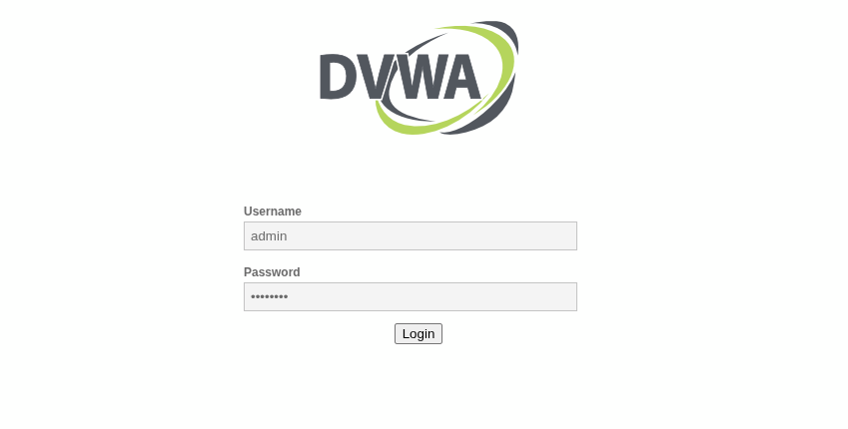
Figure 12: The DVWA login page provides access to the vulnerable web application used for security testing.

DVWA Database Setup
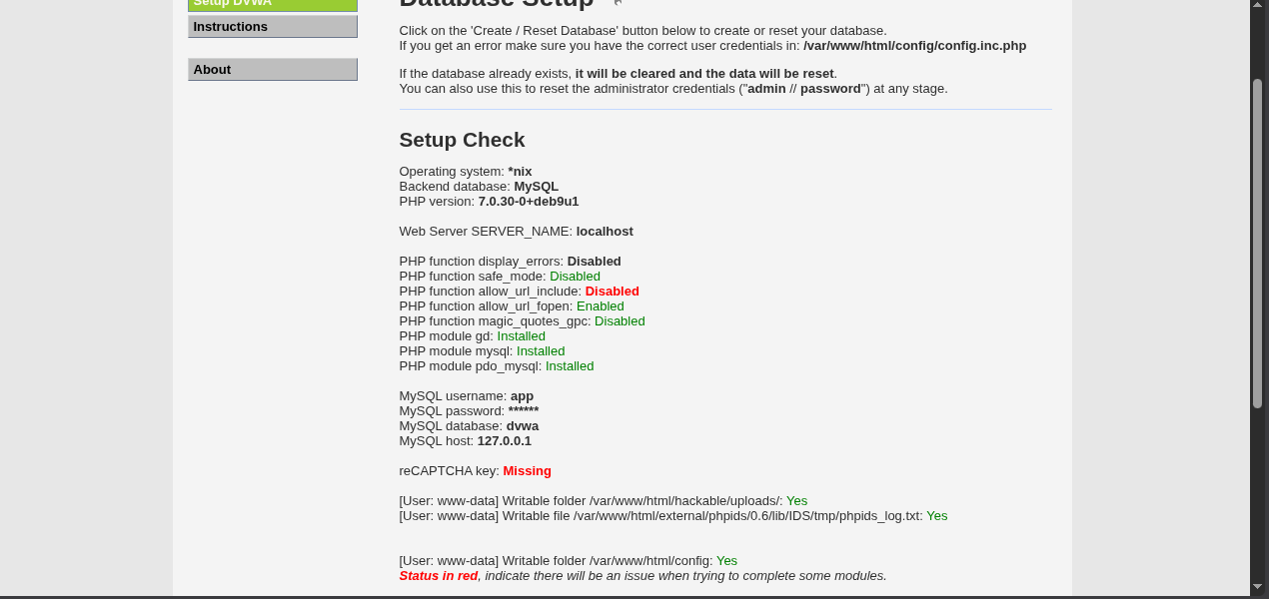Figure 13: The DVWA database setup page confirms that the application is properly configured and ready for database initialization before vulnerability testing.

SQL Injection Module
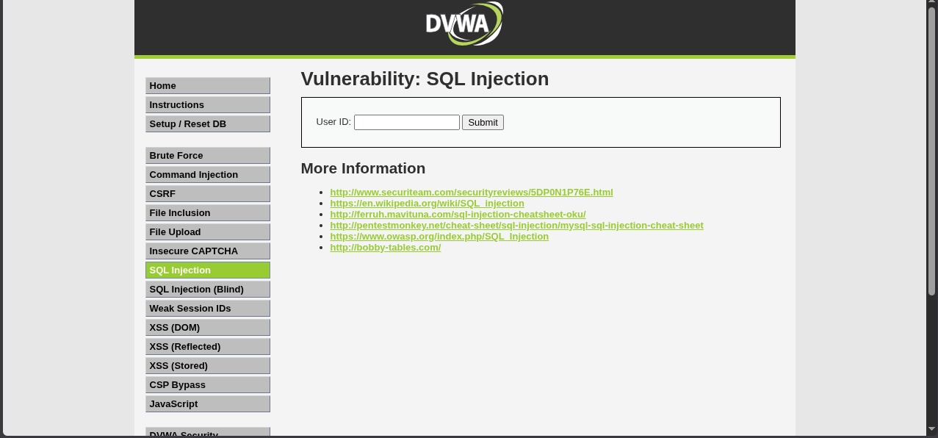Figure 14: The SQL Injection module was accessed to evaluate input handling in a controlled testing environment.

SQL Injection Test Results
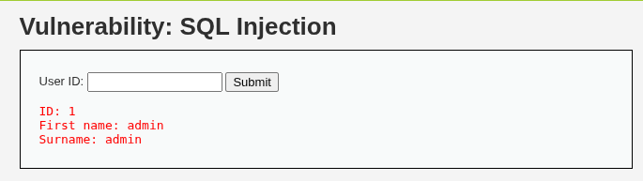Figure 15: The application successfully processed the supplied User ID and returned database records from the backend.

Retrieval of Additional User Records
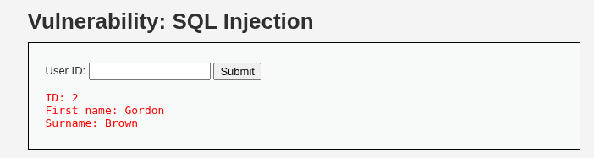
Figure 16: The application retrieved a different user record based on the supplied User ID, confirming that database queries are driven by user input.

Student reflection
This assignment gave me hands-on experience with SQL Injection in a controlled environment using DVWA. It showed how improper input validation can expose sensitive data and reinforced the importance of secure coding practices, input sanitization, and parameterized queries in web application security.

